Listed below are the two types of wireless cards used for GPRS/NetMotion connectivity.

Sony Ericsson GC82 Manager Status Window

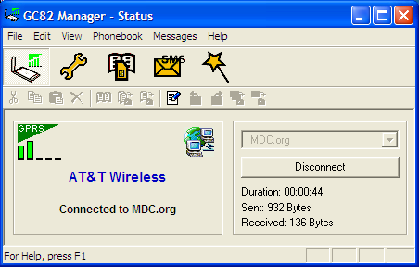

Sierra Wireless AirCard 750 Status Window

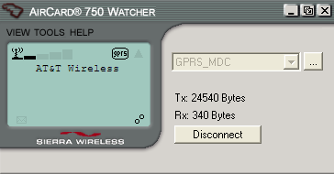

Common Connectivity Issues with GPRS/NetMotion

Error: NetMotion is not Connecting
The user will report, “I have connection to AT&T but my NetMotion client is not connecting.”
Solution:
Have the user put the NetMotion client in bypass mode.
To do this, click on the NetMotion icon at the bottom of the screen near the time display.

Then right click the icon to get the following screen.

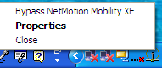

Click on “Bypass NetMotion Mobility XE”, the following screen will appear.

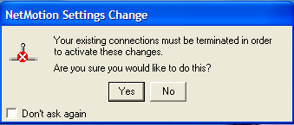

Click on “Yes”.
Bypass mode is on.

After a couple of seconds, have them re-enable NetMotion.
Right mouse click on NetMotion’s Bypass icon to get the following screen.

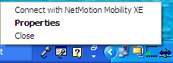

Click on “Connect with NetMotion Mobility XE”, and the following screen will appear.

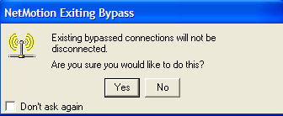

Click on “Yes”.

NetMotion will be in active mode.

The follow icon shows a successful connection.


If the problem persists, contact the NetMotion Administrator(s) for further assistance.

Error: Time out of Sync
User XXX’s (user id) date/time is too far out of sync with the server date/time for NTLMv2 to authenticate. Correct the client machines date, time, and/or time zone.
Solution:
Have the user set the date and time on their PC to the current date and time, and retry.

Error: Not in User Group
User DYYYYYYY\XXX (domain\user id) is not in the NetMotion Users group. Connection failed.
Solution:
Have the user contact their domain administrator so their user id can be added to the GPRS global group in their domain. Once that is done, connectivity will be successful.

Error: Logon Failure
User DYYYYYYY\XXX (domain\user id) attempted to authenticate. The logon attempt failed (ss=0x8009030c). Logon failure: unknown user name or bad password.
(msg =1326).
Solution:
Have the user double check the spelling of their password. Passwords are case sensitive, so have them check to make sure they do not have their Caps Lock on, when it should be off. If the problem persists, contact the NetMotion Administrator(s) for further assistance.

Error: Account Locked Out
User DYYYYYYY\XXX (domain\user id) attempted to authenticate. The logon attempt failed (ss=0x8009030c). The referenced account is currently locked out and may not be logged on to.
(msg =1909).
Solution:
Unlock the account in the users domain if you have access, otherwise a NetMotion Administrator for further assistance.

*** Error: NetMotion is not Connecting
The user will report, “I have connection to AT&T but my NetMotion client is not connecting. The card is transmitting but not receiving.” (Please see screen below.)

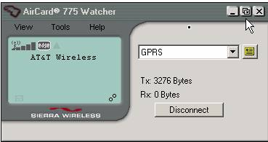

Solution:
- Ping the two NetMotion Interfaces from outside of MetroNet (209.183.59.22 & 209.183.59.54) and see if you get a response. Also, attempt to connect to AT&T and NetMotion using the appropriate APN and verify service.

- If not, go to the TP room inside the Computer Room and locate the BCN & BLN routers. On top of the BCN are two CSUs, one for MDPD - 209.183.59.54 (now MDFD) and a second for General Government - 209.183.59.22.

- Based on IP that is not responding, check the cabling from the router to the corresponding CSU and make sure it is secure. Check the LED’s on the CSUs to insure there is activity.

- Reboot the CSU in question by removing the power cable, counting to ten and then reconnecting the power cable. The device will reload itself. Watch the LCD display for the counter to reach 100%.

- Now attempt to ping the interface in question to get a response. Then connect to AT&T and NetMotion using the appropriate APN and verify return of service.

Note: Miami-Dade Police Department (MDPD), manage and maintain their own NetMotion servers for MDPD personnel only. A NetMotion error call from MDPD personnel should be directed to MDPD’s Help Desk by calling (305) 471-DESK (3375).

NetMotion Administrators

Debbie Neal – (305) 596-8439
Jorge Suarez (305) 275-7634
Keith Adams – (305) 596-8944

